Refer to the code:



you could use res.send(“html tags”) to write all the html tag but its very painful

app.get("/", function(req,res){

// res.send("<h1>welcome to home page</h1><h2>lalalalal</h2>") ;

});

ppl normally use res.render(“dog.html”) to render the html page out. But if you want to render out dynamic webpage, then you would have to use the EJS file.

res.render(“dog.ejs”)

put your ejs in the views folder

remember you will have to install the ejs package: npm install ejs –save



ejs could help us add variables to html

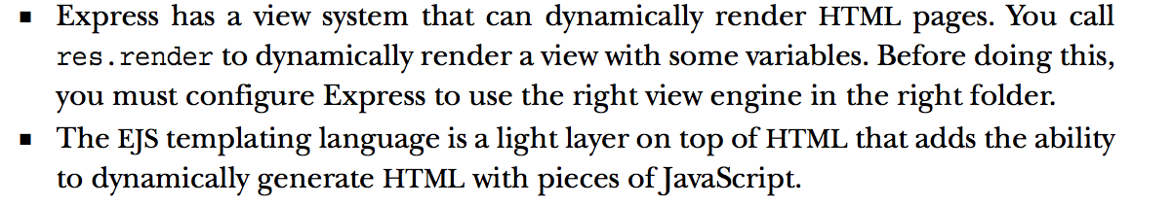





anything btw <%= %> will be treated like javascript:





summary:

#Rendering HTML and Templates

* Use res.render() to render HTML(from an EJS file)

- res.send("info"): could print out some html tag

- res.render("dog.html"): could only print out some static html page

- res.render("dog.ejs"): ejs allows us to insert js into html

**- note: express by default goes to views folder to get the view, so dont need "./views/dog.ejs" or "./views/dog.html"**

* Explain what EJS is and why we use it

-EJS: embeded javascript file: could help us embed js variables into html. so we could make our page more dynamically

* Pass variables to EJS templates

-res.render("dog.ejs", {

varName1 : varValue1 ,

varName2 : varValue2

})

-ejs: <h1>hello <%= varName1.toUpperCase() %></h1>

btw <%= %> is treated as JS first and only the result will be printed on html